NOTES: The Atmosphere – Chapter 11 Name: ________________________________ Per: ____

What does the atmosphere do for the Earth?
___________________________________________________________________
___________________________________________________________________
___________________________________________________________________
___________________________________________________________________
___________________________________________________________________
Where did the ancient atmosphere originate? (Describe in your own words)
________________________________________________________________________________________________________________________________________________________________________________
How did it become the “modern” atmosphere we lived in?
________________________________________________________________________________________________________________________________________________________________________________
How is the atmosphere measured?
Temperature - measured by ___________( Celsius, Farenheit, Kelvin)
Pressure - measured by a ____________(atmospheres, psi, mmHg, cmHg, millibars,etc.)
There are many ways to analyze the Earth’s atmosphere
Analysis of Earth’s atmosphere by Chemical composition of the lower layers (troposphere, stratosphere, mesosphere) is generally homogeneous (the same composition).
__________ Nitrogen gas (N₂)
__________ Oxygen gas (O₂)
__________OTHER: ( Argon 0.93%, Carbon dioxide 0.03%, water 0 - 4%, Ne, He, Kr, Xe, H₂, O_{3 -- OZONE})
Changing Atmosphere –
Currently _______________________ adds oxygen and removes carbon dioxide while _____________________ does the opposite. Carbon Dioxide traps ______ .
Other things we find in the atmosphere are dust, ice, chemical pollutants (NO, SO and others) and CFC’s
CFC’s are compounds found in Styrofoam and propellant sprays that _________ ________ between molecules of oxygen in Ozone (O₃), creating “holes”.
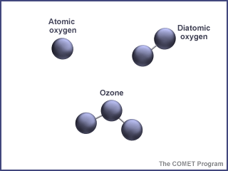
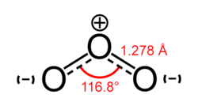

How is the Ozone critical to Life on Earth?
_______________________________________________________________
_______________________________________________________________
By Temperature trends
Mnemonic: “TR u ST ME IN TH e EX am ”
__________________________________________________________________
Changing Atmosphere – The chemical composition of the atmosphere is changed by what is added to it and what is taken away.
PHOTOSYNTHESIS_________________________________________________________________________________

RESPIRATION ____________________________________________________________________________________

POLLUTION ______________________________________________________________________________________

RAIN ___________________________________________________________________________________________

LAYERS OF THE ATMOSPHERE
The layers of the atmosphere are determined by ________________________
The ______________________ in relationship to the ____________________ is known as the _________________.
A __________ in the temperature line is called a _________________.

T____________: The layer we live in. In this layer we see a cooling trend as we rise in altitude. This is the normal lapse rate. It is the layer closest to the Earth’s surface and contains most of the water (due to its position next to the oceans) found in the atmosphere. The Earth’s weather and life is found in this layer.

S_____________: This layer is “thinner” (less dense) than the troposphere below it. It has the majority of the ozone found in this layer. The ozone absorbs much of the UV energy that comes from the sun. In this layer we see a warming trend as we increase the altitude.

M_____________: This layer is even thinner (Less dense) than the stratosphere below it. There is less than 1/10 of 1% of the air molecules in this layer. There is a cooling trend as the altitude increases. Air temperature reaches its coldest at the top of the mesosphere (-90 degree C).

T____________: This layer is extremely thin, the atoms and molecules in this layer are constantly bombarded with energy from the sun. This causes the atoms and molecules to become ions. The temperature trend here increases with altitude ( temperature is a measure of the average kinetic energy of atoms/molecules), but there are so few molecules that we wouldn’t encounter enough to transfer heat to our skin.

___________: This layer fades out to space. Earth’s gravity can’t always hold on to the molecules here.

Other “hidden” layers that overlap are. . .
_______________ Found at the top of the Stratosphere, this layer especially protects us against radiation.
________________ Found at the top of the Mesosphere and Bottom of Thermosphere, this layer is Ionized (charged
with energy) and can transmit/reflect electronic signals sent from earth to other areas on earth.
___________ ___________ is at the top of the Thermosphere, and officially marks the “end” of what matter belongs to earth via gravity.

YOU WILL NEED TO CREATE A DRAWING (8.5 by 11 inches) OF THE NEXT IMAGE IN THE POWERPOINT – IN COLOR.
It is also on the website
~~~~~~~~~~~~~~~~~~~~~~~~~~~~~~~~~~~~~~~~~~~~~~~~~~~~~~~~~~~~~~~~~~~~~~~~~~~~~~~~~~~~~~~~~~~~~~~~~~
What happens to the number of molecules as altitude increases? _______________________________________
By Mass - ___________ of the mass is in the troposphere alone!
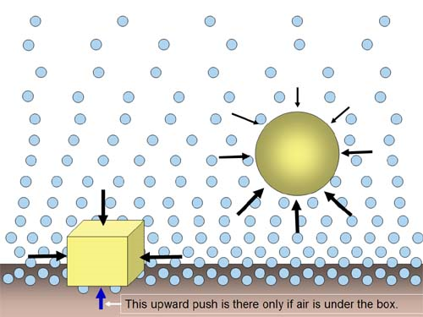
By Density – Pressure ___________ with altitude. So,
The closer to the surface you are, the ________ dense the air
and the _________the air pressure. In a closed container, as
temperature increases, the pressure ____________. In nature,
High pressure weather = _______________ weather. And…
Low pressure weather= ________________ weather. Why? ____________________________
Find out on your own:
By Mass
___________ of the mass is in the troposphere
___________ of the mass is in the stratosphere
___________ of the mass is in the mesosphere, thermosphere and exosphere combined
By density The closer to the surface you are the __________ dense the air and _________the air pressure. The troposphere has the greatest density and the exosphere has the least density.

