NOTES: Sea Floor Spreading Name: ________________________________________________________ Per____
History : Prior to the 1950’s not much was known about the ocean floor. This changed due to the work of Admiral Harry Hess, a Naval officer and a geology professor at Princeton University. Hess was intrigued with Wegener’s ideas on Continental Drift and the mechanism of continental movement. Hess presented his ideas in a paper titled “History of Ocean Basins”. What did Harry Hess hypothesize about the ocean floor? __________________________________________________________________________________________
__________________________________________________________________________________________
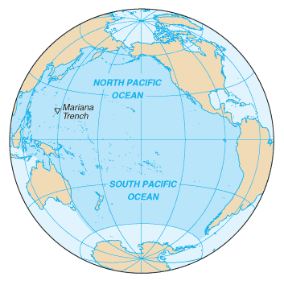
The Ocean Floor
How do we know the topography of the ocean floor? Name the technology and explain how it works._______
_________________________________________________________________________________________
What are ocean ridges and how are they formed? _________________________________________________
__________________________________________________________________________________________
What are ocean trenches and how are they formed? _______________________________________________
__________________________________________________________________________________________
Name the deepest trench in the ocean. Where is this trench located? __________________________________________________________________________________________
How do we know what the bottom of trenches look like? _________________________________________
__________________________________________________________________________________________
How does sea floor spreading work? Explain what is happening in the diagram below.
_____________________________________________________________________________________________________________________________________________________________________________________________________________________________________________________________________________
Why is the ocean floor so young? (Geologically speaking)
How old are the oldest rocks in the ocean floor? ___________________
How old are the oldest continental rocks? ________________________ Why is there a difference?____________________________________
A Geomagnetic Time Scale
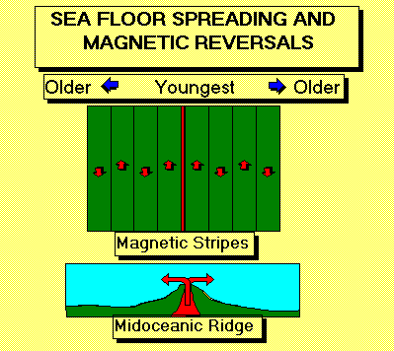
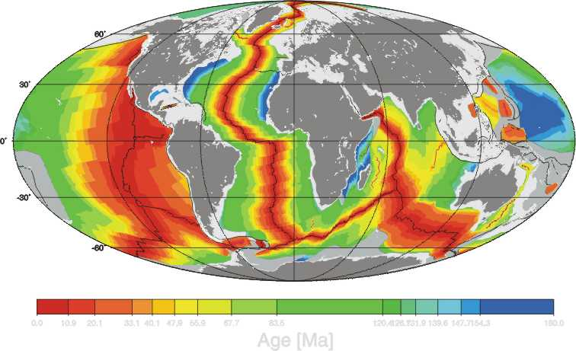
Basalt is rich in iron (remember – it’s a mafic, extrusive igneous rock). The iron-containing minerals align with the Earth’s magnetic field. Once the rock cools the minerals stay aligned. The magnetic field has reversed several times in geologic history. These flips in polarity are recorded in the rocks.
An isochron is a line on a map that connects points that have the same age. What pattern do you notice in the isochron map to the right? __________________________________________
__________________________________________
__________________________________________

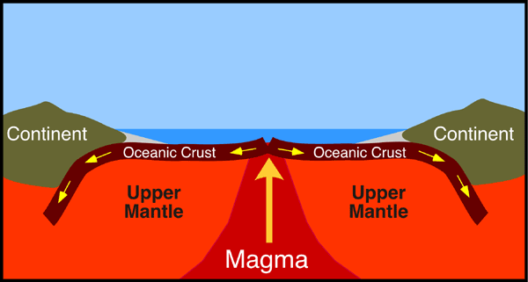
Wegener’s Missing Mechanism
How did Harry Hess provide additional evidence to support Alfred Wegener’s hypothesis of continental drift?
_______________________________________
HOT SPOTS ARE: ____________________________________________________________________________
__________________________________________________________________________________________
Example is located: _____________ Why are they not REAL volcanoes? _______________________________

