NOTES: WATER in the AIR (11.3)
We feel warmth in the air from:
1)
2)
3)
4)

Water Vapor in the air is called ________.
The air can hold _______% water vapor
____ air can hold more than ____ air.
__________ __________ is how much water vapor the air CAN hold, compared to how much it’s actually holding right then.
A _______________ is used to measure humidity.

CLOUD FORMATION happens from . .
- Condensation Nuclei:

- Coalescense:

- Condensation:

- Latent heat :
Clouds only form in lower levels of the atmosphere because:
The 3 ways clouds form are:
1) Convection:
2) Orthographic Lifting:
3) Air Fronts:
The water cycle happens because of heat energy that is absorbed or released by water vapor:
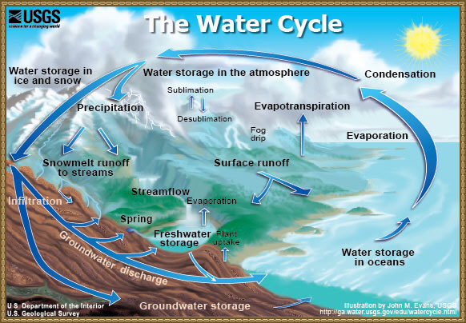

DEW is :

DEW POINT is:

