(Ch 17.3/Ch 20.2 and 20.3)
Notes: Plate Tectonics and Plate Boundaries

The Theory of plate tectonics states ____________________________________________________________
_________________________________________________________________________________________
The plates “float” on a denser plastic-like layer called the asthenosphere which is the upper part of the mantle.
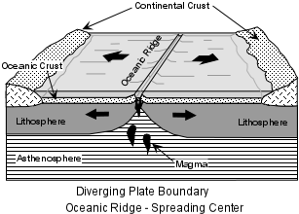
The “dynamic” parts of earth _____________, ________________, and _______________ occur along plate boundaries

Divergent Plate Boundaries

- Mountains associated with divergent boundaries are called ____.

Examples of features found at divergent plate boundaries
1)

2)

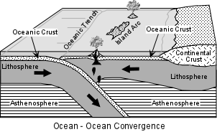
Convergent Plate Boundaries: the boundary between two plates that are colliding into one another (crust can disappear at these boundaries). There are three types of convergent boundaries.

- Two Ocean Plates collide (Ocean versus Ocean)

What happens? _________________________________

What features are formed? ______________________________________________________________________

Give some examples: __________________________________________________________________
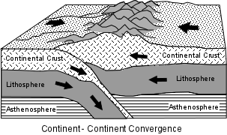
- Two Continental Plates collide (Continental versus Continental)

What happens? _________________________________

What features are formed? ____________________________________________________________________________________________________

Give some examples: __________________________________________________________________
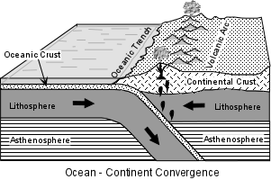
- An Ocean Plate collides with a Continental Plate (Ocean versus Continental)

What happens? _________________________________

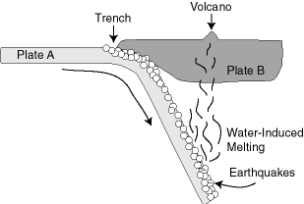
What features are formed? ________________________________________________________________________________________________________________________________________

Give some examples: ______________________________________________________________________________________________________________________

Transform Boundaries – the boundary between two plates that are sliding past one another.

What feature do you find at these types of boundaries?
_____________________________________

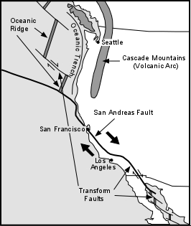
Give some examples: ______________________________

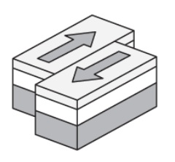
Labeling exercise. . . . 