Guide for How Students Should Save Work on School Computers

It has come to our attention that some students do not know how to save work on our school computers so they do not lose it. I wanted to make sure that my students have this guide so when you are in the computer labs you can properly save your work in your My Documents space.

- Student log into computer

- Save your document as soon as it is on the screen

- Clicks “File” menu at the top

- Click on Save As

- Go to Computer on the left hand toolbar and click on your username (highlighted below)
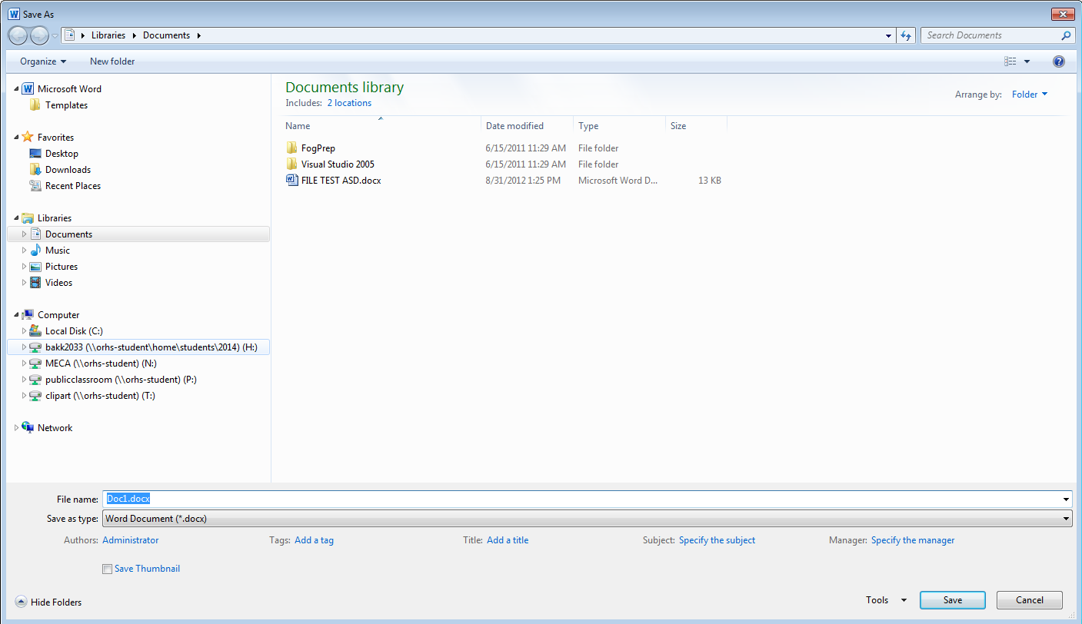

Continued Below

- Click on My Documents (Never save on the desktop)
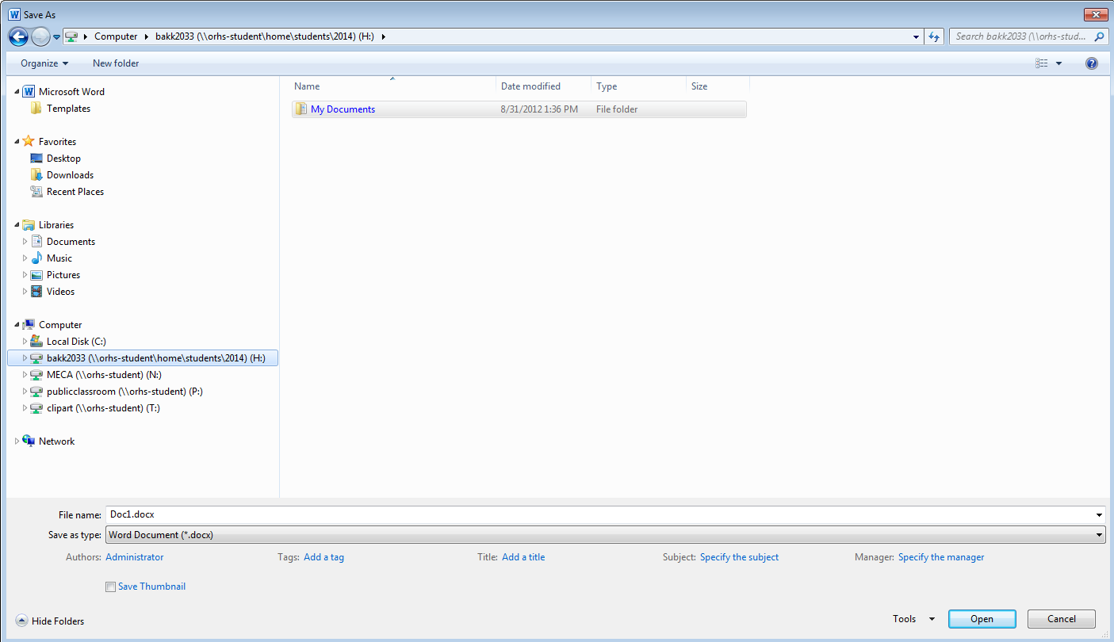

- When My Documents opens - select which subject you are working on - then hit Save

DONE!

