Name/Date/Per ________________________
Atmosphere and Elevation
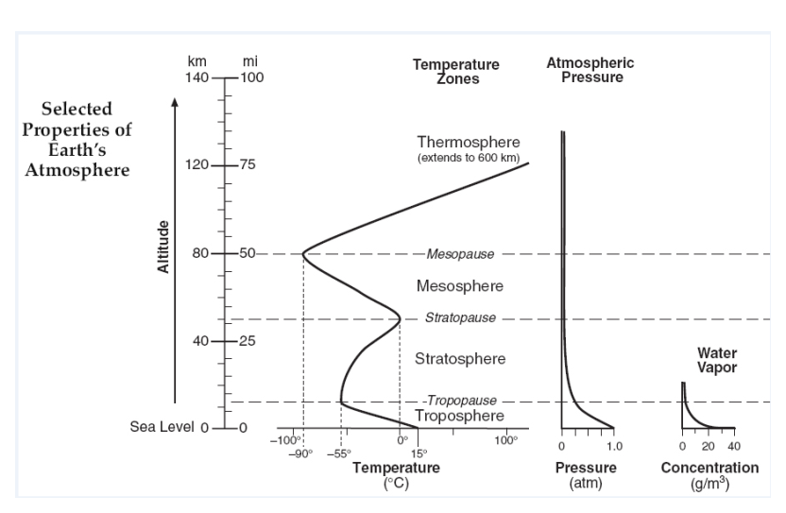

Base your answers to the following questions on the information contained in the three graphic relationships in the diagram.

- Using the words “increases, decreases, or remains the same,” correctly complete the following statements:
- As elevation in the troposphere increases, the atmospheric temperature:

- As elevation in the stratosphere increases, the atmospheric temperature:

- As elevation in the mesosphere increases, the atmospheric temperature:

- As elevation in the thermosphere increases, the atmospheric temperature:

- As elevation above sea level increases, pressure:

- As elevation above sea level increases, the water vapor content of the atmosphere:

- Explain why clouds are generally observed to form only in the troposphere.

- What is the atmospheric pressure at sea level?

- As approximately what height in the atmosphere would the atmospheric pressure be at 0.25 atm?

- List the 5 layers of the atmosphere in the table below in order from outer space to the earth’s surface, then correctly complete the table by determining the thickness of each layer, and entering the information in the appropriate spaces. (note: There is insufficient information to determine the thickness for one of the layers; Leave the appropriate space blank.) Show your math!

Layers of the Atmosphere | Thickness (in km) | Math – show subtraction
(furthest from the surface)
(closest to Earth’s surface)

- The four layers of the atmosphere are separated by thinner layers called “pauses.” What happens to the temperature at the “pauses”?

7a. At approximately what elevation does the coldest temperature occur in the atmosphere?

7b. What name is given to this point in the atmosphere?

7c. What is the temperature at this point? Include units.

8. What is the temperature at the stratopause? Include units.

