Title: Finding the Epicenter Name____________________

Introduction: Most earthquakes occur in remote areas where no one lives. They sometimes occur underwater in oceans. They may leave a scar on the land where the fault slips but sometimes they do not. Even if no one is at the epicenter (location where the fault slips) scientists can locate it. In this activity, you will learn how p and s waves are used to find the epicenter and find the location of two epicenters. You will use a principal called “triangulation”. To triangulate, you find the distance a place is from 3 other locations. Using three points, it can only be in one place. Triangulation is the same technology used in your GPS on your phones.

Materials: compass, pencil
Support: Video - https://www.youtube.com/watch?v=TBss68oBmmk

Procedure:
1. Record the p- and s- wave arrival times on your data table. Use the chart below. Each little line is about 1.5 seconds.
2. Subtract the p-wave arrival time from the s-wave time to find the lag time.
3. Use the Travel Time Chart to determine the distance from the epicenter.
4. Use the scale in the middle of the maps to find the distance from the station.
5. Use the compass to draw a circle around the station the correct distance from the epicenter.
6. Do all four stations (the fourth station is for accuracy). The epicenter is the place where at least three of the circles meet. Put a star on that spot.

Data:
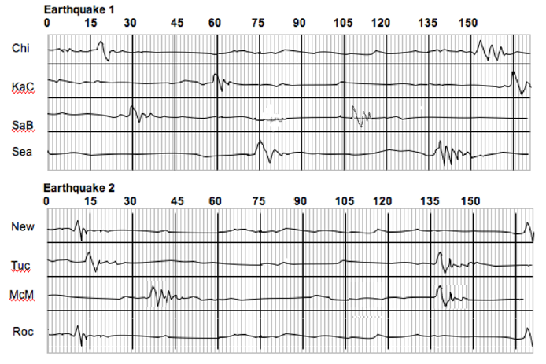

Data Table:
Earthquake 1
Seismographic Station City | p-wave arrival time | s-wave arrival time | Lag Time | Distance from City
Chicago
Kansas City
Santa Barbara
Seattle

Earthquake 2
Seismographic Station City | p-wave arrival time | s-wave arrival time | Lag Time | Distance from City
Newport
Tucson
Rockville
McMinnville

Analysis:

1. Between the S & P wave, which one arrives first? Why?

2. What instrument recorded the information from the p and s-wave arrival times?

3. Why didn’t the p-waves arrive in each city at the same time?

4. Does the lag time get shorter or longer the further you get from the epicenter?

5. How could you prove an epicenter was where you calculated it to be?

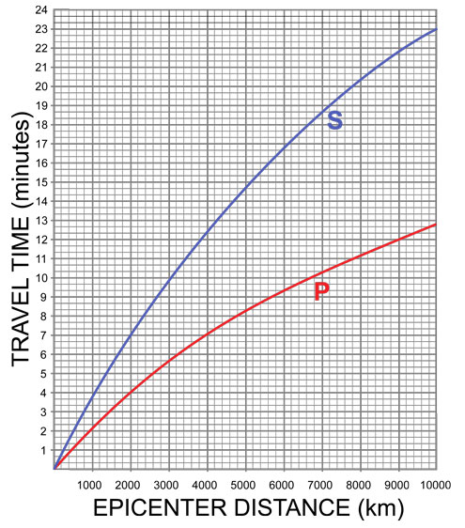

Conclusion:
Write a conclusion for this exercise below. Describe your findings and use data to help in your description.

