Protons:
Electrons:
Neutrons:
Orbital/Shell:

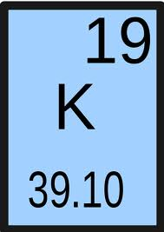
Atomic Number:

Atomic Mass Number:

Finding Neutrons (isotope) example:
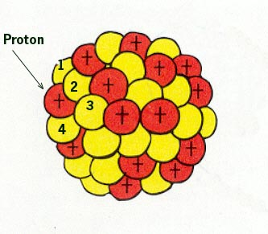
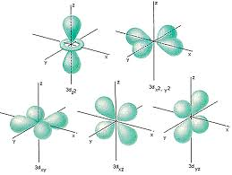

Isotope:

Decay:

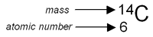
(Isotope Notation of Carbon-14)
List all information you
Know from this notation:
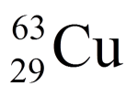
An Element is: _____________________________________________________________0, 0-0 or 0-0-0…
A Molecule is:______________________________________________________________0-0 or 0 – X
A Compound is:_____________________________________________________________________ 0 - X

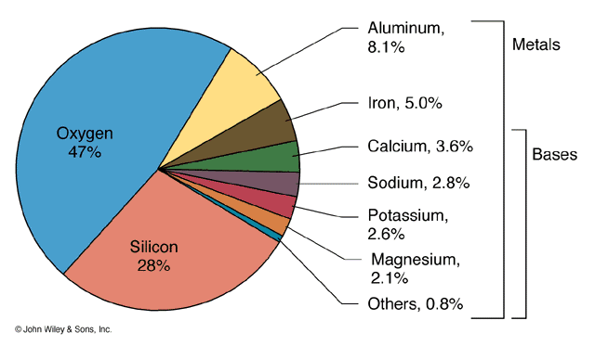
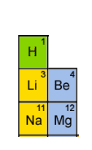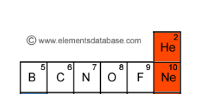
Memorize the names and atomic numbers of the first 12 elements below, and the top two most common elements in the earth’s crust from the graph!
Elements in the Earth’s Crust

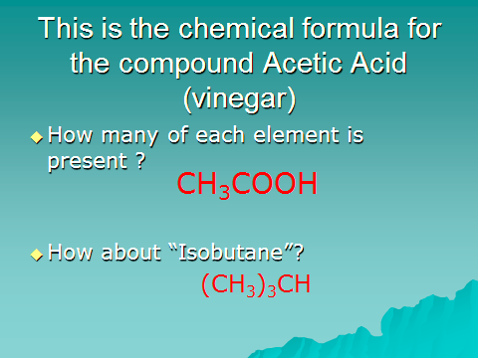

SOLUTIONS are:_________________________________________________________________
Which DO / DO NOT involve chemical changes.
Solute:
Solvent:
In Geology, the mineral ______________________ has formed giant crystals underground in Mexico.
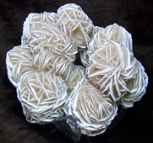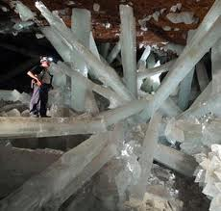
A solution of the rock Limestone can create ___________________________ when it drips slowly from the roofs of caves.
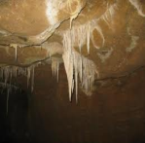
MIXTURES are:______________________________________________________________________
Which DO / DO NOT involve chemical changes.
Homogeneous:
Heterogeneous:
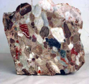Conglomerate = __________________ mixture (large, course, visible grains)
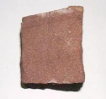Sandstone = _________________ mixture (small, non-visible grains)
What can the following elements do to the appearance of rocks and minerals?
Potassium: Manganese: Iron: Calcium:
Turns pink/orange
WHY do atoms bond with each other?
____________________________________________________________________________________________________________________________________________________________________________________________________________________________
THE REASON IONIC BONDS ARE FOUND IN GEOLOGY:
1)

2)

3)

THE REASON METALLIC BONDS ARE FOUND IN GEOLOGY:
1)

2)

3)

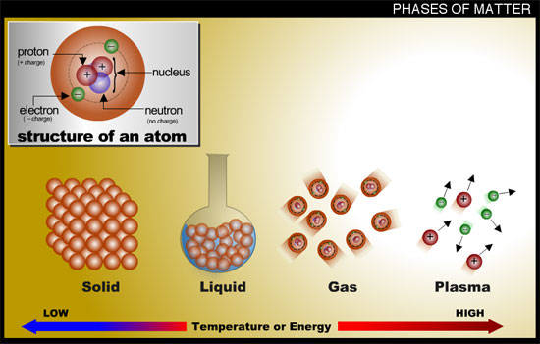
WAYS TO CONVERT BETWEEN ANY TWO PHASES OF MATTER:
Condensation:

Evaporation:

Sublimation:

Freeze:

Changes can occur to matter by adding or taking away ___________.

