Name: ___________________________________P# _____
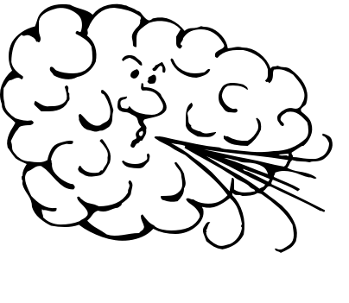
Global Wind Patterns

- Label the latitude lines with their degree north or south of the equator. Label the equator.
- Draw the air cells circulating around #1-12. Be sure to put arrows on your cells to show which way they are flowing. Name each cell.
- Place arrowheads on the lines representing the surface winds, showing the direction they blow. Name all the winds and the windless areas.
- Label High (H) and Low (L) pressure areas around the globe.
- Write the number(s) of the items that are labeled on your diagram

4 Temperate Air Cells____________ 1 Doldrums ____________
4 Polar Air Cells _____________ 2 Horse Latitudes ________
4 Tropical Air Cells (Hadley Cells) __________
2 Prevailing Westerly Winds _____________
2 Polar Easterly Winds ____________
2 Trade Winds ____________
 | Points | Earned
Identification of items by numbers above | 8
Polar Easterlies | 2
Prevailing Westerlies | 2
Tradewinds | 2
Horse Latitudes | 2
Doldrums | 1
Equator | 1
Correct High and Low pressures | 2
Wind direction arrows | 3
Convection Cell direction and names labeled | 4
Degrees Latitude Labeled | 3
Total | 30 / 2 =  15 points

