NOTES: THE LAYERS OF THE EARTH
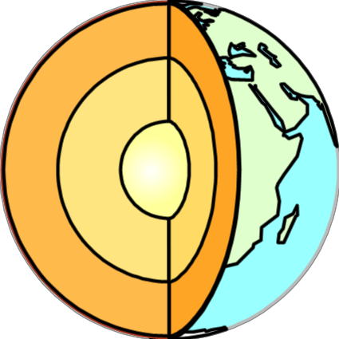Inner Core Outer Core Mantle
­­Lower mantle
­­Upper mantle
Asthenosphere (very top layer of the mantle)
Lithosphere 6 5
­­ Continental and Oceanic Crust 4 3
2

1

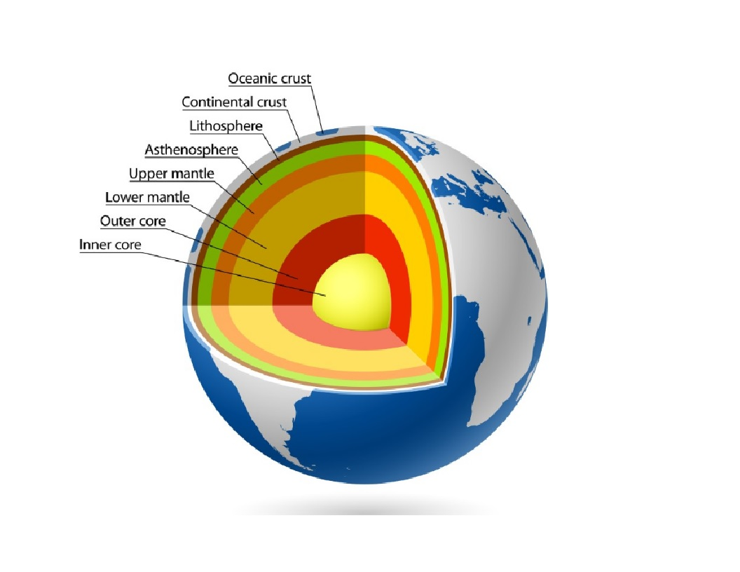
Why is CONSISTENCY important?

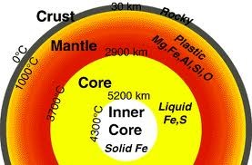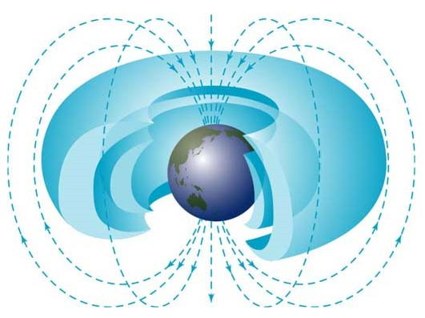The solid inner core spins inside of the liquid outer core, which creates a magnetic field called the . Magnetosphere

The earth has layers because of density.
The heavier elements are found
The plates of the rocky Lithosphere float and roll across the top of the plastic/gooey Asthenosphere.

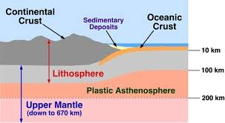 at the solid inner core, with the lighter liquid layers above. The crust is more solid because it is exposed to the air and cooled.

Recent information has altered the number of different layers in the core to the following: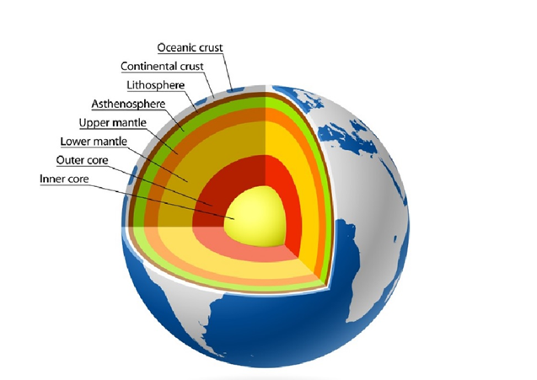

The Lithosphere is broker apart into chunks called PLATES.

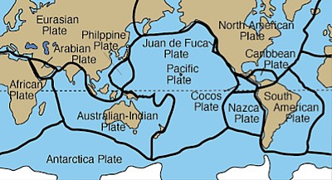

These plates are set in motion from CONVECTION CURRENTS in the mantle, which roll the plates along like a conveyor belt.

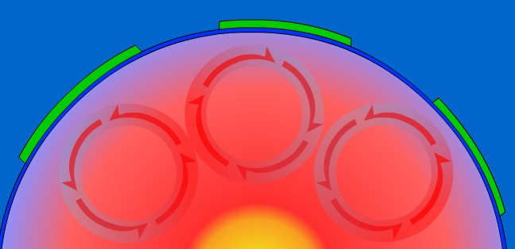

EXTRA INFORMATION:

- Magma rises to the surface where two convection cells rotate away from each other

- Crust collides and sinks/wrinkles where two convection cells rotate towards each other

- Convection cells spin due to hot fluids rising from the inner core, and cooled fluids sink from the surface.

- Cooler materials = more dense(heavy)

- Warmer materials = less dense (light)

Convection Currents

