Name: _______________________________ Period # _____
Chem, Rocks, Minerals Crossword – Make-up Lab for______________________________
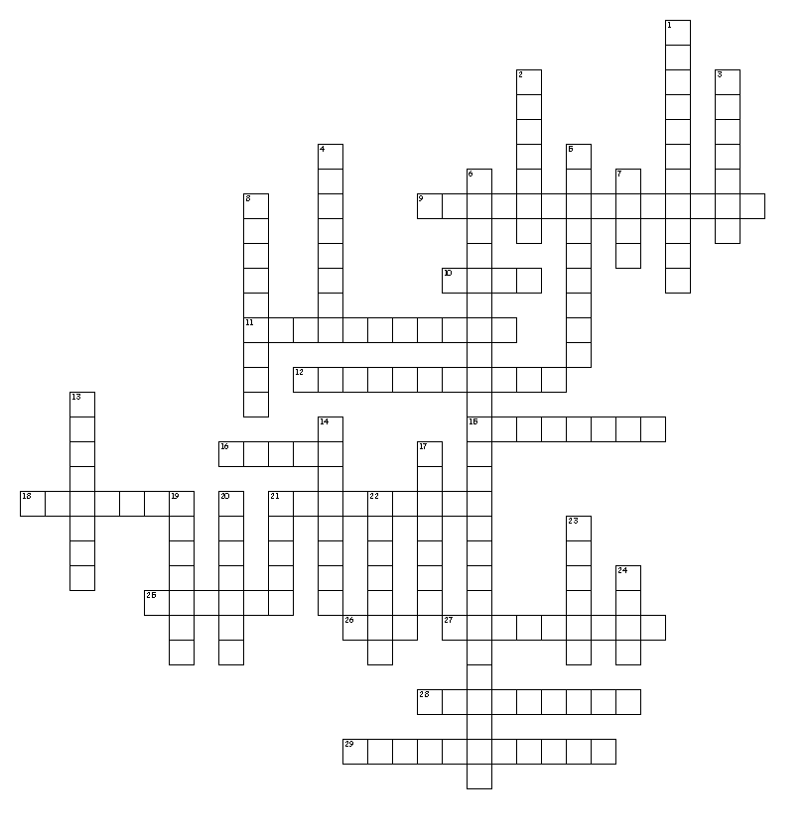

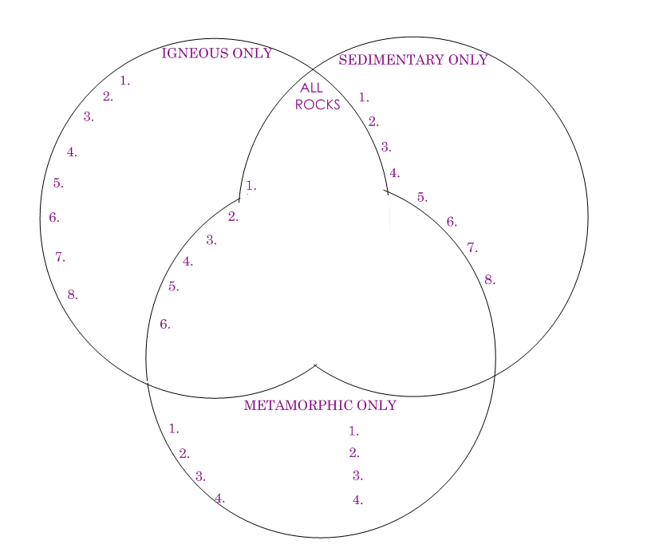

Across
9. Different minerals melt at different temperatures.
10. Basic unit of matter.
11. Changing state from a solid to gas.
12. Metamorphic rock with blocky crystal shapes.
15. Two or more different atoms bonded together.
16. Molten rock found beneath earth's surface.
18. Type of intrusive igneous rock that is very common in the sierra nevada mountain range.
21. Pieces of solid material that have been deposited on earth's surface by wind, water, ice, gravity, or chemical precipitation.
25. A state of matter that has no definite shape but does has a definite volume, molecules slide across each other.
26. A state of matter that has no definite shape or volume.
27. Minerals that contain silicon and oxygen (the most common group of minerals on earth).
28. Type of igneous rock with larger crystals formed from cooling slowly.
29. Rock formed from heat and pressure.

Down
1. Only type of rock made up of pieces of other rocks (also can find fossils in them).
2. Type of sedimentary rock formed from the remains of living things.
3. A pure substance, made up of one type of atom.
4. Type of sedimentary rock formed when minerals precipitate out of a solution.
5. Process by which intrusive igneous rocks are eventually exposed to weathering and erosion.
6. The process where different minerals form at different temperatures.
7. Valuable minerals that are prized for for their rarity and beauty.
8. Type of igneous rock with very small crystals/grains.
13. Type of metamorphic rock formed from intense pressure, flattening the crystals into bands.
14. How easily a mineral can be scratched.
17. Mass per unit volume.
19. The movement of sediments from one place to another.
20. A combination of two or more substances not bonded together.
21. A state of matter that has a definite shape and volume, molecules are tightly packed together.
22. A naturally occurring, inorganic solid with specific chemical composition and definite crystalline structure.
23. The color of a mineral in it's powdered form.
24. Minerals that contain a substance that is valuable.

