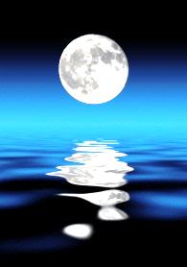MOON STUDY GUIDE (use 28.2, 28.3 in book)

Decorate your moon below with the following features and LABEL each of them!
- Impact craters
- Ejecta rays
- Regolith
- Maria and highlands
- rilles

