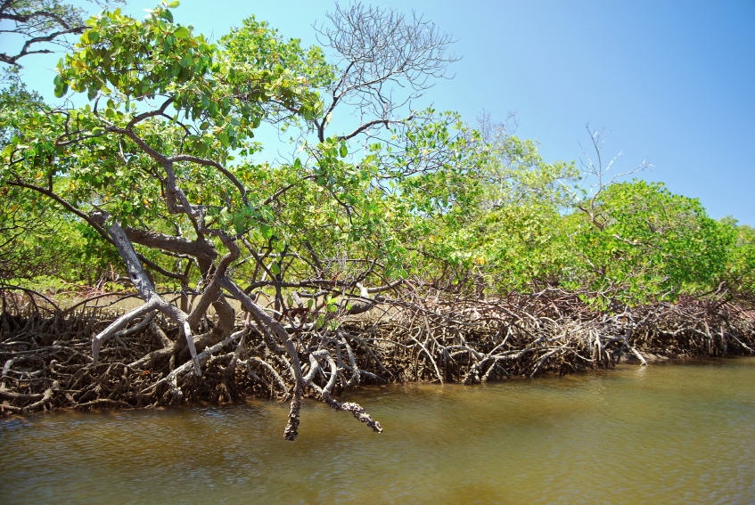NOTES: Creating Climate(14.1&14.2)
CLIMATE is:

A “climatograph” is:
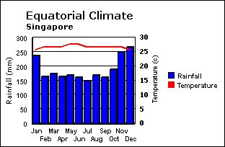
Climate comes from these 3 factors:
1)___________(___________________________________)
2)___________(___________________________________)
3)___________(___________________________________)

1) Latitude:
Angle of Incidence:
The earth is tilted _______ on it’s axis. If the sun is lower in the sky (small angle of
incidence) , then solar energy will be spread out __________________________.
The 3 main climate zones that come from the sun are _________, _________, and ____________ .
2) Topography:
Topography means ___________________________. The other factors included in this group are. . .
- Elevation ( _______________________________ )
- Color ( ___________________________________)
- Texture( _________________________________ )
- Specific Heat (_____________________________)

These factors cause different areas of land to retain more heat than others:
Dark colors heat up quickly because. . .

Textures absorb more radiation because . . .

Low specific heat substances will . . . .
Elevation affects climate in 3 ways:
(1) (2) (3)

3) Fluids: Water and Water Vapor have a very high specific heat! This prevents great fluctuations in temperature.
The closer you live to water, then. . . ___________________ = _________________________ = ___________________________ = ____________________ = _________________________ = ________________________________________
The __________________________ is a major warm ocean current which promotes desert spreading in the middle of continents, and also warmer climates to cities with a higher latitude that are closer to the coast.
The __________________ and the ______________________ Air Masses contribute to weather and climate in California, since they “soak up” the temperature of the ocean they sit on top of.

