NOTES: Earthquake Origins
An earthquake is the vibration of earth, caused by a __________________________________________________________________________________________________.
This energy radiates in all directions from its source, _____________, in the form of _______________ .
The media usually only discusses the ________________ of an earthquake, because it’s the place on the ground above the _____________ that people can actually see.
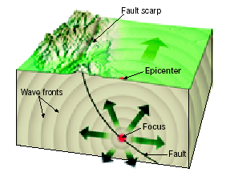
SEQUENCE OF FORCES INVOLVED IN AN EARTHQUAKE:
- Stress:

- Strain:

- Elastic Limit:

- Elastic Rebound

Earthquakes are the result of movement along ___________________________________________________________________________________________________________,
But mostly at __________________________________.

(The fault we are closest to, which hosted a lot of Gold in the 1800’s is called the _____________________________.)

Earthquake energy travels through the ground in the form of ______________.
A higher energy wave will have a higher ______________, and a shorter ____________________.
High-energy waves are more destructive than low-energy waves in most materials, but in the crust of the earth the SLOWEST ones are worst!
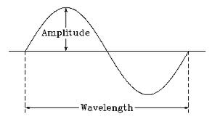
Type of Waves: | Description of Motion Behavior: | Other characteristics:
- PRIMARY (P)  Motion: |  | 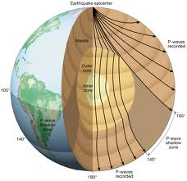
- SECONDARY (S)  Motion: |  | 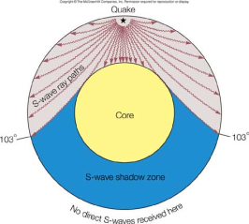
- SURFACE  Motion: |  | 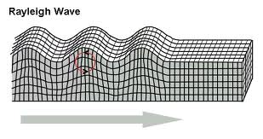
Ways to measure earthquakes:
SEISMOGRAPH:
Lag time:
RICHTER SCALE:
MERCALLI SCALE (also Rossi Forel):

