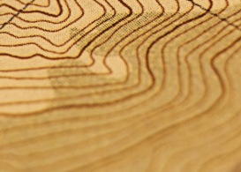NOTES: TOPOGRAPHIC MAPS
SLIDE #1 | (TITLE)
SLIDE #2:  A _______________________ map is like a road map.  A _______________________ map shows 3-D features. | 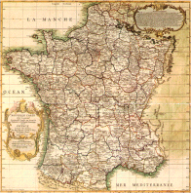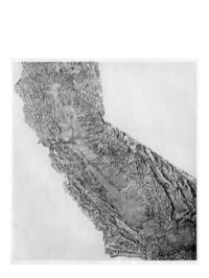
SLIDE #3:  _____________________________is the 3-D characteristics of land.  A _______________________ map shows distance  And elevation together. | 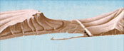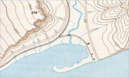
SLIDE #4/5/6: | ( Discussion)
SLIDE #7: (Drawing space here. . . . .) | 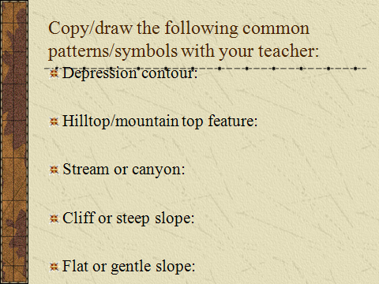
SLIDE #8: FRACTIONAL Map Scale:
1)

2)

3)

4)

5)
SLIDE #9/10:
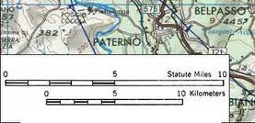

A______________ map scale is shown as a bar that you use to _______________________________________

The ____________ the second number on a
Fractional map scale, the ______________the detail
You’ll see on the map

SLIDE #11:  An ______________ contour line has a number on it.  A ______________ contour line does not. | 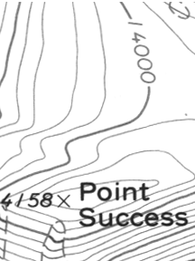
SLIDES 12/13/14: Basic Contour Line RULES:  1)  2)  3)  4)  5)  6)  7)  SLIDE #15/16/17:  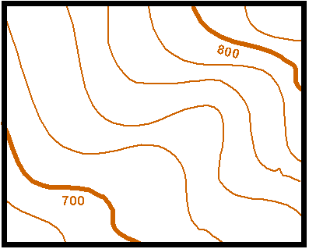  A contour INTERVAL is _______________________________________  The INTERVAL formula is: | 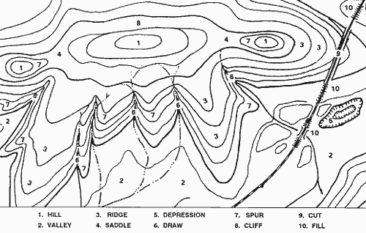
SLIDE #18: (Show work here) | 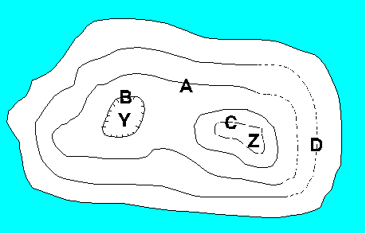
SLIDE #19:  A ___________________ is a known elevation at a specific point.  It is usually symbolized with ___________ or ___________ next to the elevation number | 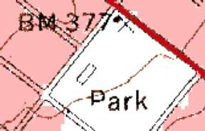
(PART II – Topographic Profiles—To be illustrated after lab. . . .)
DISCUSSION QUESTIONS/ANSWERS ?

