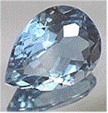 List the characteristics that classify minerals from other substances:
(1)
(2)
(3)
(4)
(5)
- Almost 4000 have been identified
- A few are _____________ -- made of only one element that exists by itself, (such as gold or copper) and also rock-forming elements.
- Most are _____________
- Sometimes, compounds are only mineral _________________(ice, diamonds) but not in others.
- A ________ is a very valuable mineral that is prized for it’s appearance.

minerals have a chemical group in their formula which gives them distinct
characteristics. Here is a summary of the top 3 mineral families/groups. . .
MINERAL CHEMISTRY

Most
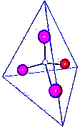
- Silicates ( - SiO₄)

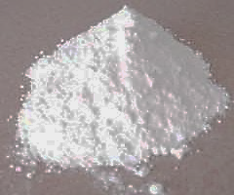
- Carbonates: ( - CO₃)

- Oxides / Hydroxides: ( - OH / -O₃)
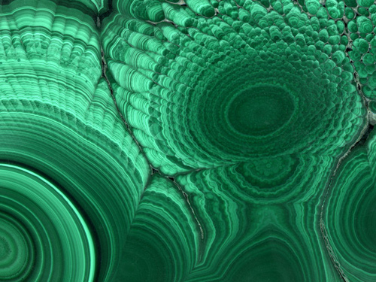

MINERAL IDENTIFICATION:
There are many tests and observations that scientists use to find the identity of 4000+ minerals! However, here are some of the common ones:
TEST/OBSERVATION | DESCRIBE OR DEFINE:
Hardness (Moh’s Hardness scale)
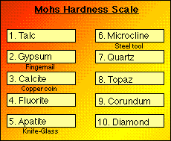
Crystal shape/form  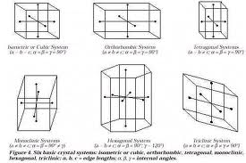 | WHAT 4 THINGS ARE NEEDED TO GROW A CRYSTAL?  1)  2)  3)  4)
Luster
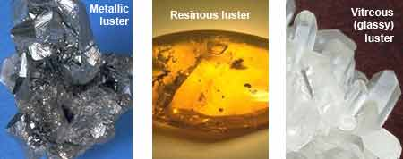
Color / Streak:
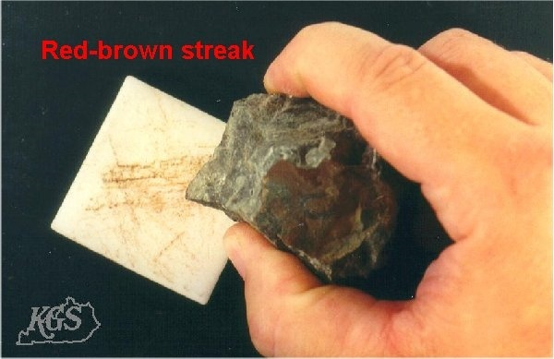

Cleavage vs. Fracture:
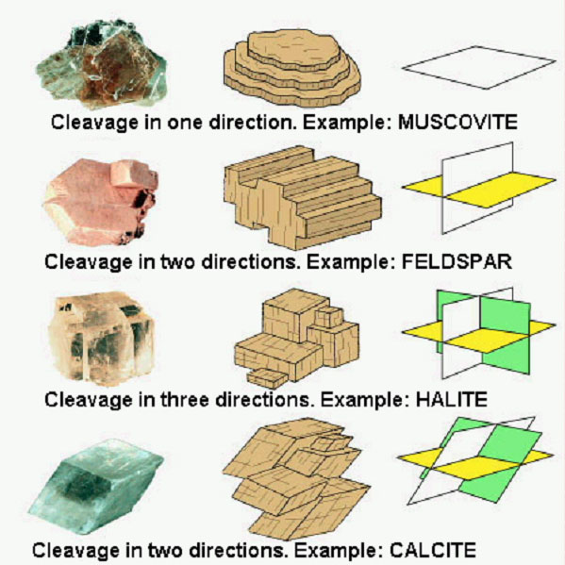
Misc. tests:
- Specific Gravity –

- Acid –

- Flourescence –

- Taste –

- Magnetism –

What is an ore?

