**Showing Measurement Graphically** Name_­­­­­­­­______________________ P.#

Independent Variable:

Dependent Variable:

***Label* where the I (Independent) and D (Dependent) variables go on data tables/graphs:**

|  |  |
| --- | --- |
|  |  |
| Plant #1 | 5 in |
| Plant #2 | 10 in |
| Plant #3 | 15 in |

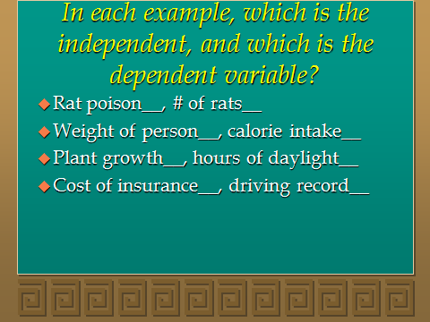

**Example: How many of each kind of variable in a graph?**

Graph A has _____ “I” variable(s) and _____”D” variable(s)

Graph B has _____ “I” variable(s) and _____”D” variable(s)

Graph C has _____ “I” variable(s) and _____”D” variable(s)

