Name: ____________________________________ Period# ______

Phases of the Moon Activity
We have all witnessed that our view of the moon changes in a predictable manner. Sometimes we see a full moon, sometimes it is a sliver. In this activity you will investigate the pattern of those changes during the moon’s cycle around earth. A light bulb or flashlight will represent the sun. You will draw and name the various phases that you observe.
DIRECTIONS – Stand in one spot so that you face the “sun”. Hold your “moon on a stick” in front of you. Notice that the side of the moon facing you is dark. This represents the “New Moon”. Keeping your moon out in front of you, rotate counter-clockwise and observe the changes in the moon’s surface. Watch the right hand side of the moon as it gets lighter, then darker. You will draw the named phases of the moon after making your observations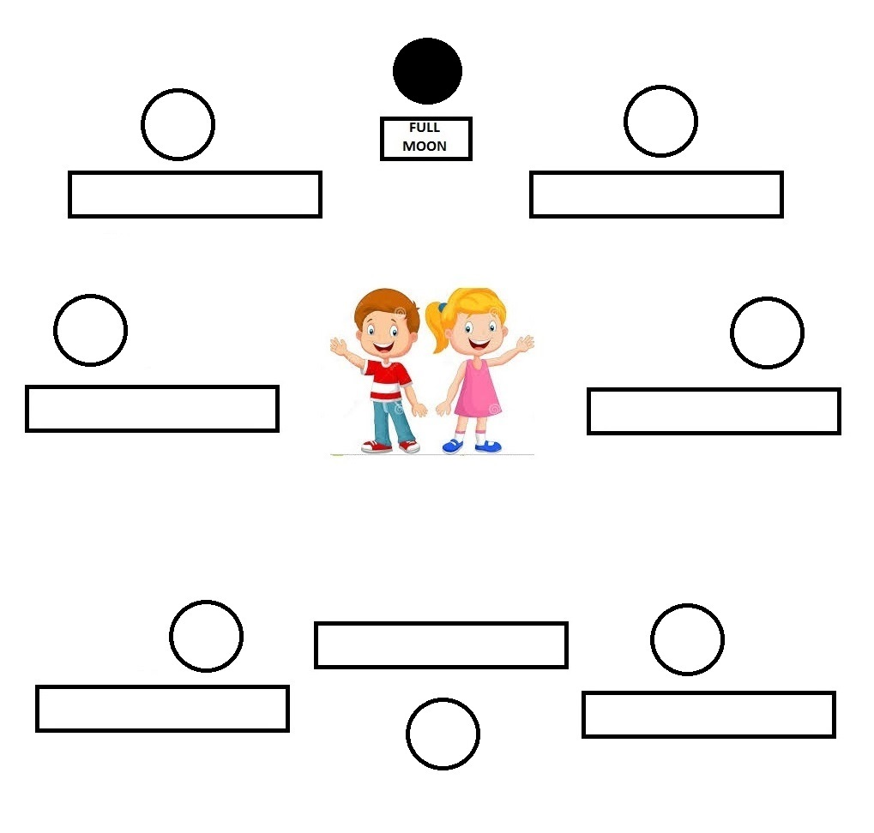

Phases of the Moon Analysis

1. What do you (the boy and girl in the center of the chart) represent in this activity?

2. Why do we only see one side of the moon (the man in the moon is always looking at us)?

3. What is a “new moon”? What does it look like? Why does it look this way? You may wish to include a diagram showing the position of the sun, earth and moon in your discussion.

4. When we see a full moon at sunset, will it be in the east or the west? Explain how you know your answer is right by illustrating it below. Show the positions of the earth, sun and moon. Label the Earth’s EAST and WEST.

5. Which phase follows a full moon?

General MOON questions (see section 28.2 in your book)
6. Who were the first humans to land on the moon? When did this occur? What was the name of the spacecraft?

7. Describe the temperatures on the moon’s surface? Why is there such an extreme range?

8. Why is the surface of the moon so cratered as compared to Earth’s surface?

9. Are there such things a “moon quakes”? Explain.

10. Read about the various theories regarding the formation of the moon. Explain the most commonly accepted theory of moon formation.

