Dynamic Earth- SAVE in Google Science folder
Plate Tectonics Interactive @ http://www.learner.org/interactives/dynamicearth/index.html

EARTH’S STRUCTURE:
Crust: Hard and rigid, it’s earth’s outermost and thinnest layer. It is only _______ km thick under the oceans, and ______ km thick under the continents.
Why do you think there’s a difference in thickness between oceanic crust and continental crust?

Mantle: Located directly below the __________, subdivided into ____ regions it is ________km thick and made of a dense layer of __________________________.

Asthenosphere: The plates float on this _____, _________ ______________ zone in the __________ __________, directly underneath the ____________________.

Outer Core: It is the only ______________ layer of earth. It is made of a sea of ________ and ________.

Inner Core: Extremely hot _________ layer of mostly __________ and ____________.

Why do you think the core is made up of iron and nickel?

Why do you think the inner core is solid?

PLATE TECTONICS:
The plate tectonics theory states that the earth’s outer layer or ____________ is broken up into several large slabs called _________________. These plates, which hold continents and oceans, are slowly _____________________________________________________________________. This theory not only supports the continental drift theory, but explains how and why ________________, _________________, and other ____________________________________ occur.

PLATES:
Continental plates are ________________ and _____________ usually ___________km thick.
Oceanic plates are _______________ and ______________ usually ____________km thick.

Define “plateboundary”:_________________________________________________________________.

PLATE BOUNDARY MAP: Label each plate on your map (back of this packet)

*Take the Plate Boundaries Challenge. Record your score here: SCORE: _______/22

Slip, Slide and Collide
BOUNDARIES:
Many of the most dramatic geologic phenomena we experience on Earth - _______________________, _____________________, ________________________ - and more are caused by the slipping, sliding, and colliding of tectonic plates at their boundaries.

Each kind of plate boundary is associated with particular events, so if you know about the movements taking place at a plate boundary, you can often predict what's likely to occur there — volcanoes, earthquakes, mountains, trenches — in the future!

CONVERGENT PLATE BOUNDARIES

- Color and label each boundary diagram. Use RED for the asthenosphere, BROWN for the lithosphere, BLACK OR GREY for the crust, BLUE for water and GREEN for the surface of land.

- Provide a specific feature found at each type of boundary. Also, list the plates that interact to create this feature. Example (which you may NOT use): The Cascade Volcanic Mountain Range is created at the convergence of the Juan de Fuca and North American Plates.

CONTINENTAL PLATE VS. OCEANIC PLATE

Example:
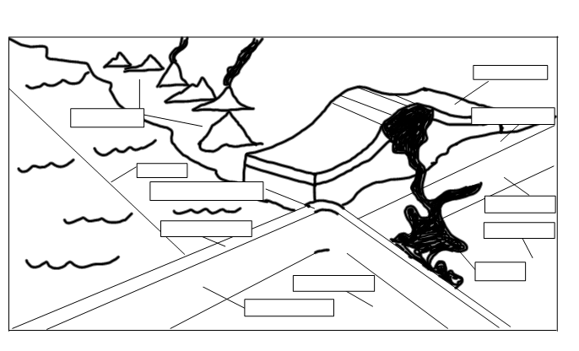
Why does the oceanic plate get forced under the continental plate?

As the oceanic crust sinks, what is formed under the ocean just off the coast of the continent?

Do you think this process has occurred here in California along the west coast of the North American Continent (looking at your tectonic plate map will help you answer this question)? What geologic evidence that you’ve seen here in California would support your answer?

OCEANIC PLATE VS. OCEANIC PLATE

Example:
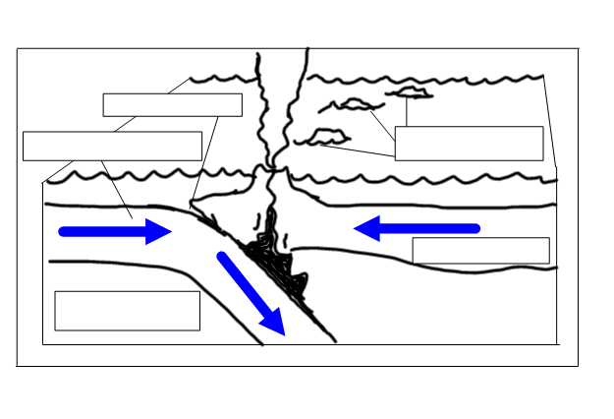
What type of land forms are created when two oceanic plates collide?

Which U.S. islands were formed by this process?

OCEANIC PLATE VS. OCEANIC PLATE

Example:

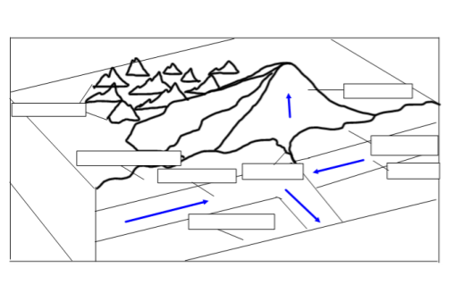

DIVERGENT PLATE BOUNDARY
A diagram is NOT provided for an ocean-ocean divergent boundary. Explain how a mid-ocean ridge forms at this type of boundary.

Give an example of a specific feature found at an O-O divergent boundary. Include the specific plates that diverge.

The diagram below shows a continent-continent divergent boundary.
Example:
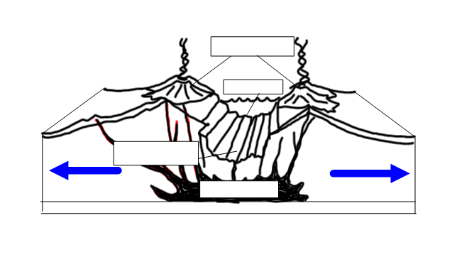
Define RIFT:

The widening crust along the boundary may become thin enough that a piece of the continent breaks off, forming a new tectonic plate. At this point what may happen?

TRANSFORM OR STRIKE/SLIP BOUNDARY
Example:
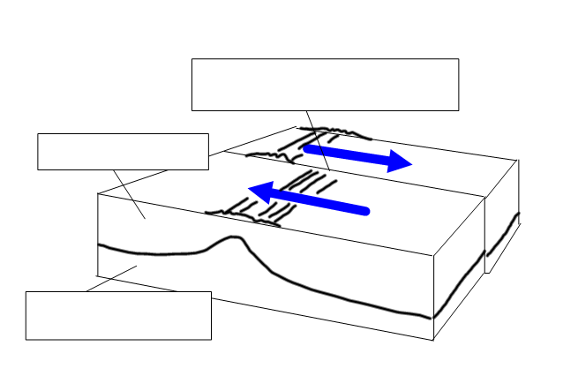

What is the best studied strike/slip fault? Where is it located?
PLATE INTERACTIONS CHALLENGE:
Be sure your read all the facts and observe the pictures before you take this quiz. It will be graded for accuracy! YOU MUST WRITE OUT EACH ANSWER!

- What is happening at the plate boundary where the African Plate and the Arabian Plate meet?
Answer:

- What geologic event is most likely to occur at this plate boundary in the future?
Answer:

- What’s happening at the plate boundary where the Australian Plate and Pacific Plate meet?
Answer:

- What geologic event is most likely to occur at this plate boundary in the future?
Answer:

- What’s happening at the plate boundary where the Nazca Plate and South American Plate meet?
Answer:

- What geologic event is most likely to occur at this plate boundary in the future?
Answer:

WORD SCRAMBLE SCORE: __________/10

Go to “Test Skills” and take the test at the end of the interactive. You may use your notes. Remember this is in preparation for your Plate Tectonics Test

TEST SCORE: __________/30

