NOTES: Evidence for Continental Drift (17.1,17.4)
Who was Alfred Wegener?_______________________________________________________
The evidence he presented included the puzzle-like fit of the continental coast-lines, evidence from rock formations, fossil evidence and ancient climate evidence.
A. It looks like all the continents should fit together!
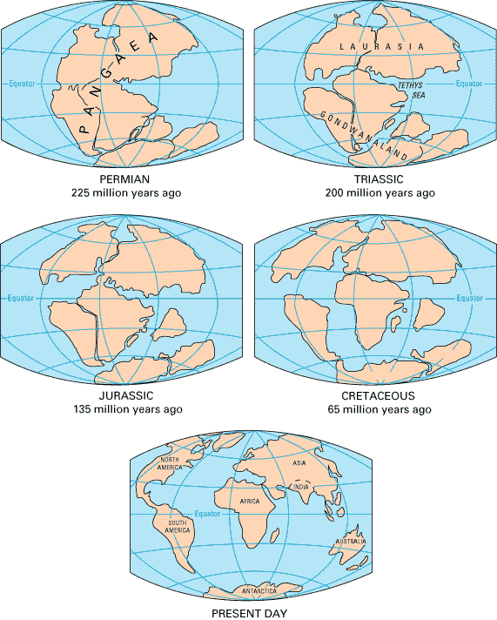
Wegener is not the first scientist to propose this idea. He proposed that all the continents were once joined as one giant “supercontinent” which he called Pangaea which is Greek for “all the Earth”.

B. Evidence from Rock Formations
There are rock formations that are older than 200 million years located in the _________________
_______________________________________
These mountain ranges formed before the breakup of Pangaea.
C. Fossil Evidence
How does the Mesosaurus fossil provide evidence of continental drift?
The Mesosaurus is a __________________
The fossils were found in ____________________
There is no way that the freshwater Mesosaurus could have swam across the Atlantic Ocean – there for the continents of S. America and Africa could have been joined .
How does the Glossopteris fossil provide evidence of continental drift?
The Glossopteris is _______________________________________________________________.
These ferns grow in tropical climates so this shows that the places where the fossils were found could have been at one time near the equator.
D. Ancient Climate Evidence
Coal Beds:

Glacial Deposits:

NOTES: Evidence for Continental Drift (17.1,17.4)
Why was Wegener’s Hypothesis rejected?_____________________________________________
_______________________________________________________________________________
2 Facts against the theory- 1) _______________________________________________________
______________________________________________________________________________
2) ____________________________________________________________________________
______________________________________________________________________________

E. Modern Theories Emerge
How do the plates of the crust actually move around?
Convection currents are: ____________________________________________________________
Slab-pull is: ______________________________________________________________________
________________________________________________________________________________
The Modern “THEORY OF PLATE TECTONICS” says:
1)_______________________________________________________________________________
________________________________________________________________________________
2) ______________________________________________________________________________
________________________________________________________________________________

Questions you want to bring to discussion when we go over notes?

