C:\Users\Owner\AppData\Local\Microsoft\Windows\Temporary Internet Files\Content.IE5\1SVXRREF\MC900031061[1].wmfPROBLEM SOLVING LAB: Identifying an Igneous Rock through Chemistry

**Part I: Learning to Use the Schematic Diagram**. *We will be learning to use the classification chart located on the last page of your Igneous Rocks notes. You will need a pair of colors that blend to make a new color.*

1. What kind of rocks are both extrusive and mafic? Color the “extrusive” area one color, and mafic another color to find out (the overlapping area will show you the answer). ________________________

[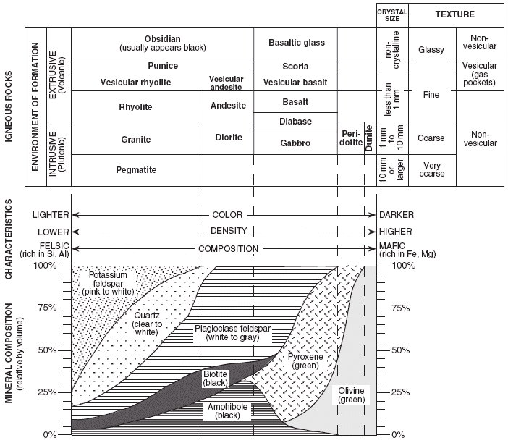](http://www.google.com/url?sa=i&rct=j&q=&esrc=s&frm=1&source=images&cd=&cad=rja&docid=xE6NZG8vwkvlTM&tbnid=2Ng7T_zD2f_HqM:&ved=0CAUQjRw&url=http://castlelearning.com/review/reference/earth9.htm&ei=1z4xUpXCB-XOigLbkoCwCA&bvm=bv.52109249,d.cGE&psig=AFQjCNHw--gHMPZVaMyMmoF_cG1UXhOAtw&ust=1379045449009714)

1. What kind of rocks are Felsic and non-vesicular? Color the first one and the second one differently to find out. __________________________________________________________________________

[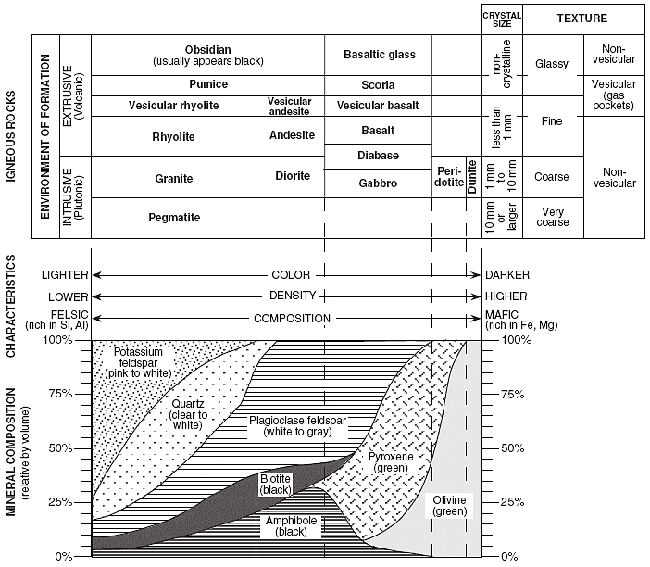](http://www.google.com/url?sa=i&rct=j&q=&esrc=s&frm=1&source=images&cd=&cad=rja&docid=xE6NZG8vwkvlTM&tbnid=2Ng7T_zD2f_HqM:&ved=0CAUQjRw&url=http://castlelearning.com/review/reference/earth9.htm&ei=1z4xUpXCB-XOigLbkoCwCA&bvm=bv.52109249,d.cGE&psig=AFQjCNHw--gHMPZVaMyMmoF_cG1UXhOAtw&ust=1379045449009714)

1. What kind of a rock would have fine-grained crystals, is extrusive, non-vesicular, with a medium density? Pick 2 colors and 2 patterns (like dots or stripes) to locate the rock type where they overlap: _____________________.

[](http://www.google.com/url?sa=i&rct=j&q=&esrc=s&frm=1&source=images&cd=&cad=rja&docid=xE6NZG8vwkvlTM&tbnid=2Ng7T_zD2f_HqM:&ved=0CAUQjRw&url=http://castlelearning.com/review/reference/earth9.htm&ei=1z4xUpXCB-XOigLbkoCwCA&bvm=bv.52109249,d.cGE&psig=AFQjCNHw--gHMPZVaMyMmoF_cG1UXhOAtw&ust=1379045449009714)

1. Find out the mineral composition of an average sample of Basalt. (Your teacher will walk you through the process.) List each mineral and it’s percentage below:

[](http://www.google.com/url?sa=i&rct=j&q=&esrc=s&frm=1&source=images&cd=&cad=rja&docid=xE6NZG8vwkvlTM&tbnid=2Ng7T_zD2f_HqM:&ved=0CAUQjRw&url=http://castlelearning.com/review/reference/earth9.htm&ei=1z4xUpXCB-XOigLbkoCwCA&bvm=bv.52109249,d.cGE&psig=AFQjCNHw--gHMPZVaMyMmoF_cG1UXhOAtw&ust=1379045449009714)

__________________________ = ____%

__________________________ = ____%

__________________________ = ____%

__________________________ = ____%

**Part II: Identifying an Unknown Igneous Rock**. *You will do the “Problem Solving Lab” on page 110 of your text book. You will also need a plastic grid counter, a calculator, and the classification chart we just used.*

1. Turn to page 110 of your book.
2. Put the plastic grid counter over the picture shown. This picture is showing the interlocking crystals of an unknown igneous rock in a thin slice (cross-section).
3. Holding the grid counter onto the picture firmly so it doesn’t move, **count how many squares** you see **each mineral touching** (no matter how big or small the color appears in the square). List them here:

Plagioclase (Feldspar) = _____ squares

Quartz = ______squares

Biotite (Mica) = _____squares

Amphibole (Hornblende) = ______squares

1. What is the total number of squares you just counted from all 4 minerals?

_______ total squares

1. Complete the following data table:

|  |  |  |
| --- | --- | --- |
| ***Mineral Type in Sample*** | ***Number of Squares counted*** | ***Percentage of Mineral in Sample***  (# of squares counted in step 3 / total squares in step 4) |
| Plagioclase (Feldspar) |  |  |
| Quartz |  |  |
| Biotite (Mica) |  |  |
| Amphibole (Hornblende) |  |  |

1. Use the percentages you just calculated to guess the identity of the igneous rock. Use the percentage bar on the right side of the classification diagram.

My guess could be this/these rocks; ________________________________________ because _______________________________________________________________________________________________________________________________________________________________________________________________________________________________________