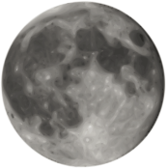
Name ________________________
The Universe (History Channel) Season 1
“The Moon”
- https://www.youtube.com/watch?v=zhx2DBxucV8
- How many moons populate our solar system? List the number of moons that the planets possess.

- What did the Romans call the moon?

- What do astronomers refer to the Earth-Moon system as?

- What is the mean distance from the Earth to the moon?

- What temperatures does the Moon shift between?

- Why did the fine dust of the moon become an issue for the astronauts?

- What creates mountains on the moon?

- How many days in the lunar cycle?

- How many high tides are there in a day?

- Who developed the first telescope?

- What theory did Edward Roche develop?

- What was the main problem with his theory?

- What did George Darwin realize?

- What occurred on July 20, 1969 that changed history?

- Where did Apollo 11 land?

- What did the astronauts bring back from the moon?

- How do the various isotopes in moon rocks and earth compare?

- What are the big basins on the moon?

- What is the name of Hartman and Davis’ theory of moon formation?

- Why would NASA want to create a base on the moon? List two reasons.

