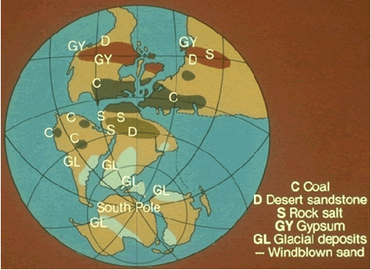
FIGURE 1 FIGURE 2
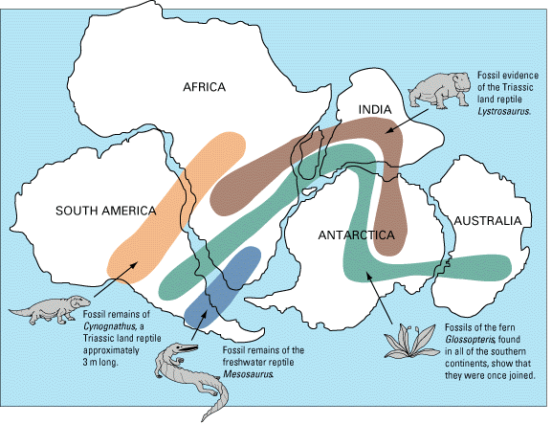
PALEO-EVIDENCE Name:_______________________________________________________________P___
For Continental Drift . . .

- On figure #1, Label the following land masses: North America (NA) , South America (SA) Africa (A) Greenland (G) Antarctica (AN) , Australia (AU) , and Eurasia (E)
- For Coal to form, there had to have once been a tropical climate. On which land masses from #1 could there once have been a tropical climate? Why does this seem strange today?

- What do you think the presence of Rock Salt on a continent would indicate about the past? Why?

- Evidence of Glaciers are found on what land masses in Figure 1 ? What does this mean about the location of the land masses now, and where they might have been in the past?

- There have been parts of the Appalachian Mountain chain that runs through the Eastern US found in Northern Europe! What does that suggest?

- How are pollen grains or seed pods important when studying Continental Drift? How about land animals vs. swimmers? How about freshwater animals vs. sea creatures? Explain all of these after analyzing Figure 2.

